July 24th. 2011
Hi
Not too much to write about.
For my exercise 'warm-ups', I have not done any running/walking for a while. All have been on the cross-trainers which, as I mentioned last week, is good. Did four days of swimming this past week. Increased the distance slightly but nowhere near the distances I was doing last season. In one of the swims, I got my time down to about 24 min/km. As there was a thunderstorm warning up, it was possible the pool might close so I was probably going a bit faster to ensure I did not have to cut my swim short.
As you will know, the space shuttle 'Atlantis' returned to Earth, ending the 30-year shuttle programme.
Read in the SCMP (and in the latest Time magazine) that there have been 7 500 aftershocks (20+ a day) in Christchurch since the 7.1 hit.
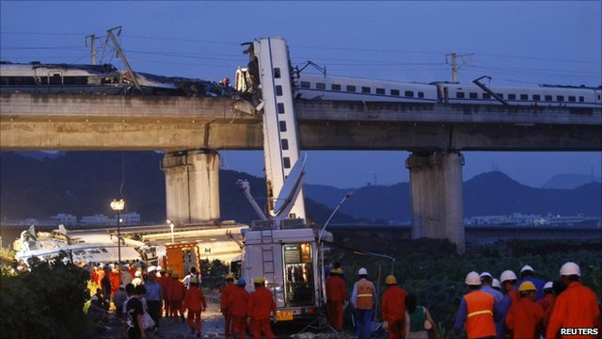
Last night, two Chinese high-speed bullet trains were involved in a high-speed collision which left 33 dead and nearly 200 injured. The first train had been halted by a lightning strike and was rear-ended by the second. These were not the latest high-speed trains which are capable of speeds over 300 km/h but were the first generation of bullet trains, with an average speed just short of 160 km/h. By comparison, Japan has had bullet trains for nearly 50 years now, and have not suffered one fatality (I believe that is correct). There are fears that corruption has compromised safety in China's high-speed rail construction
The Southern hemisphere international Rugby season has begun. Last weekend, Australia were embarrassed by being beaten by Samoa but they made up for it yesterday by beating SA 39-20. On Friday, the ABs had their first game, beating Fiji 60-14, though the winning margin was not as great as in some of their previous encounters. Of course, after the Tri-nations, there will be the Rugby World Cup.
That's about it.
Cheers

